Function Spaces & Fourier Series

Fourier Series Problem Set

Team:

Carpe Noctem

Team Leaders:

Michael Sangillo

Team Members:

Carlos Lazo, Christopher Rappa, Jake Tisdale, Michael Sangillo

Course: TDC1

Instructor: Glenn Berger

Group Hours: 15 hours

Date Submitted: 11/24/08

PROBLEM # 1

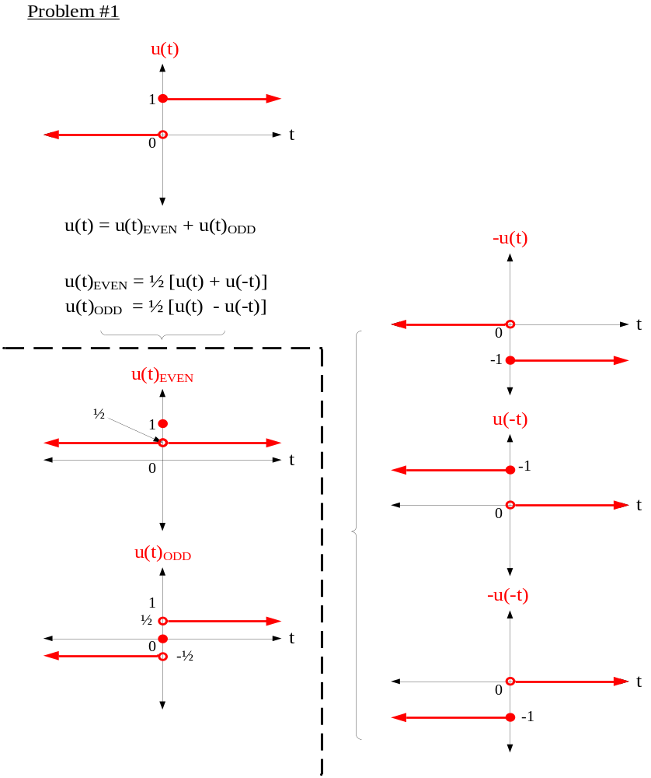

PROBLEM # 2

** Part A **

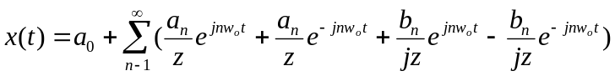
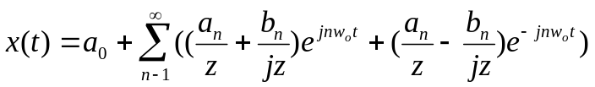
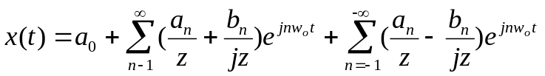
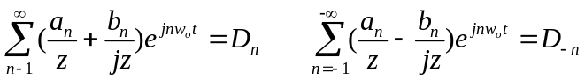

For real 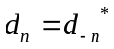 see part b for proof
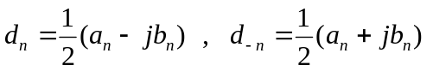
Even: 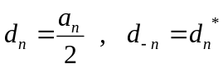
Odd: 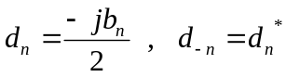

** Part B **

If real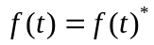
For all t,
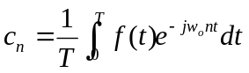
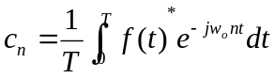
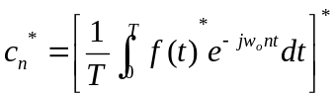
Substitute “n” for “–n”
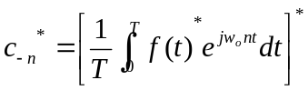
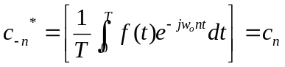 QED
PROBLEM # 3

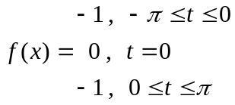

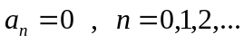
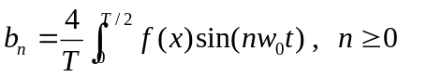
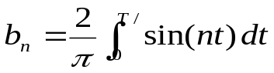

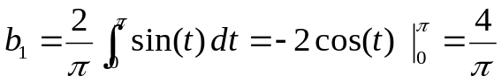
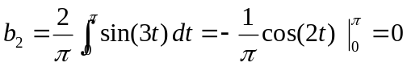
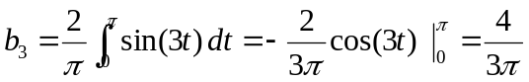
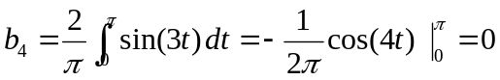
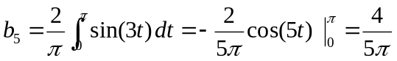

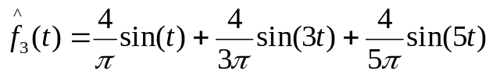
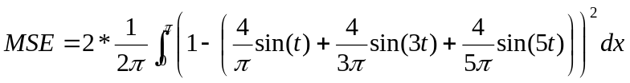
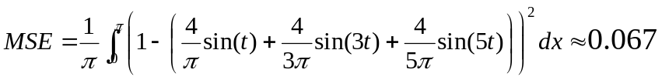

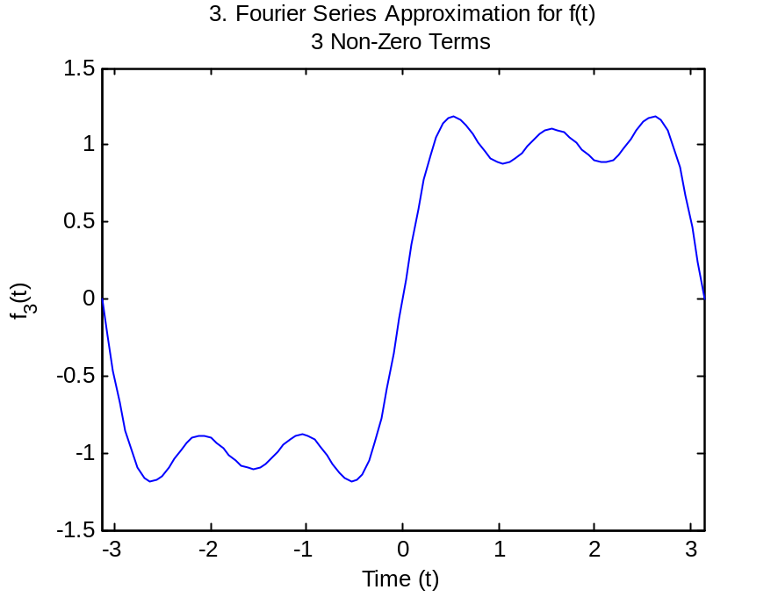

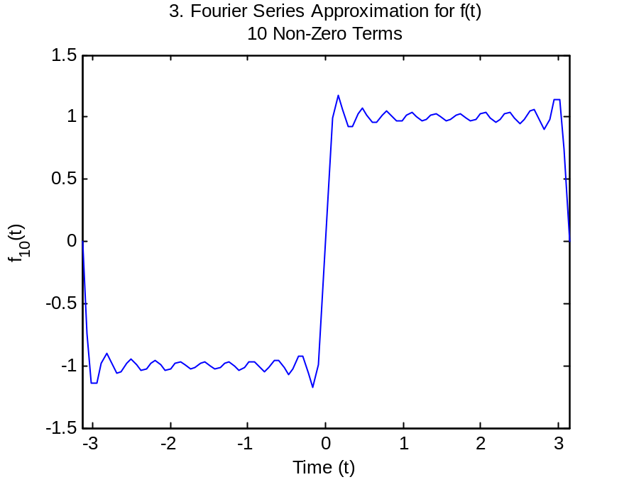

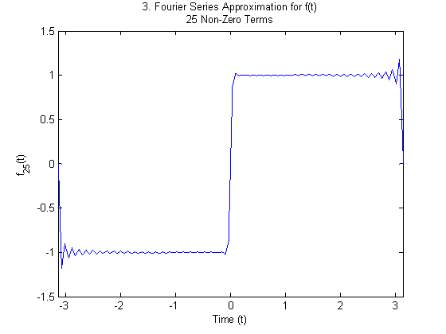

PROBLEM # 4

** Part A **

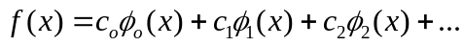
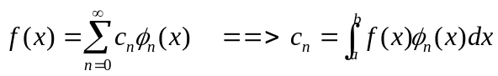
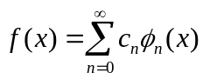
Integrate both sides over [a,b]:
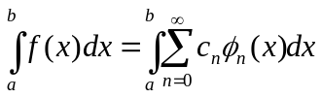

Multiply by some orthogonal function with fixed integer iteration (φ_{m}(x)):
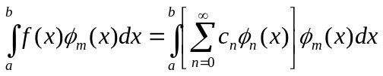

Distribute integration:
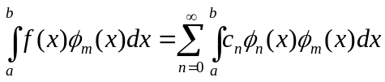

Substitute orthogonality relationship (from Mathworld):
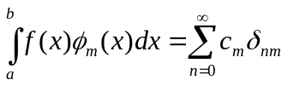

Evaluate summation:
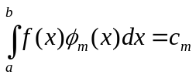

Substitute n=m:
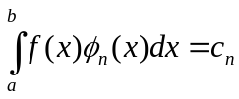
QED

** Part B **

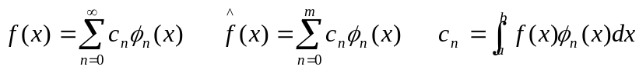
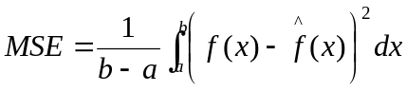
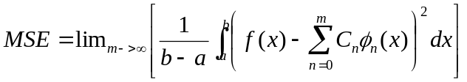
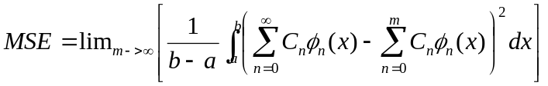
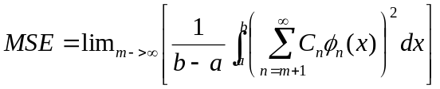
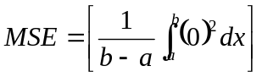
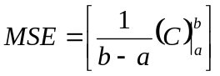
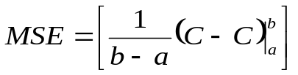
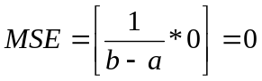

PROBLEM # 5

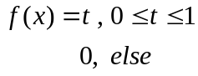
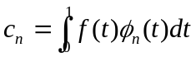
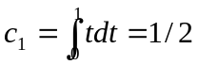
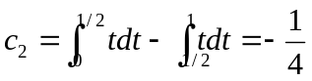
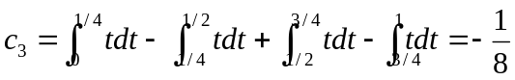

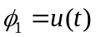
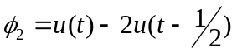
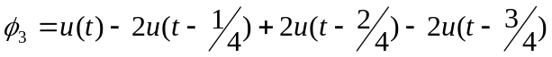
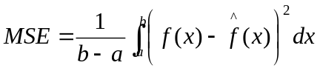
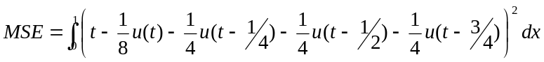

PROBLEM # 6

** Part A **

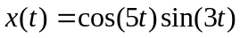

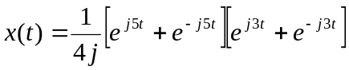
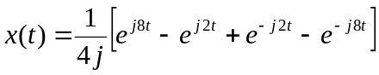
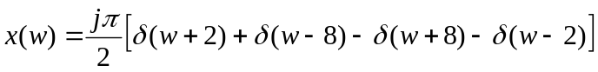

** Part B **

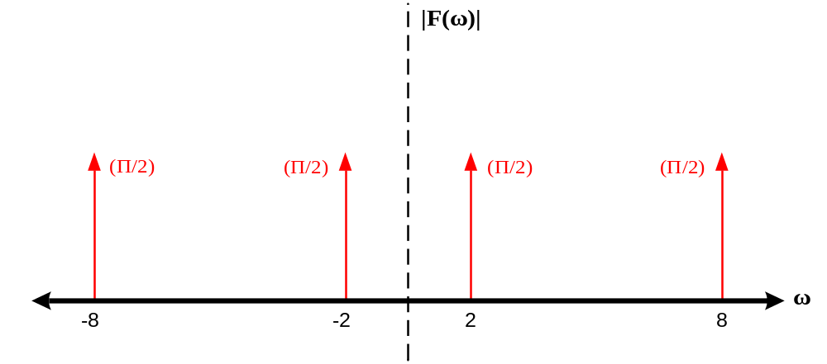

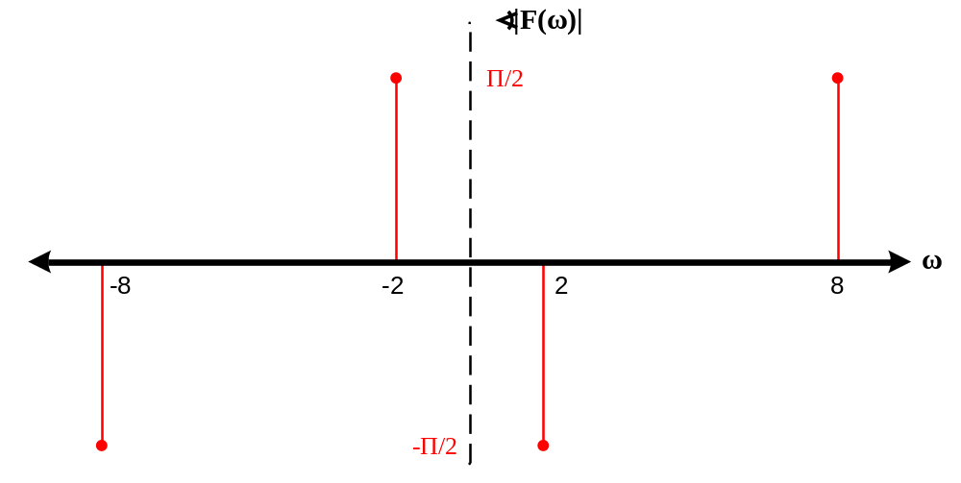

** Part C **

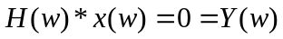

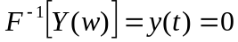

PROBLEM # 7

** Part A **

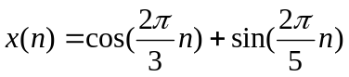
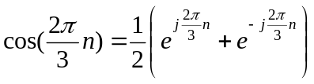
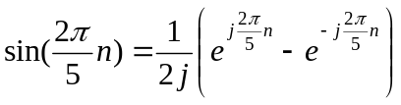

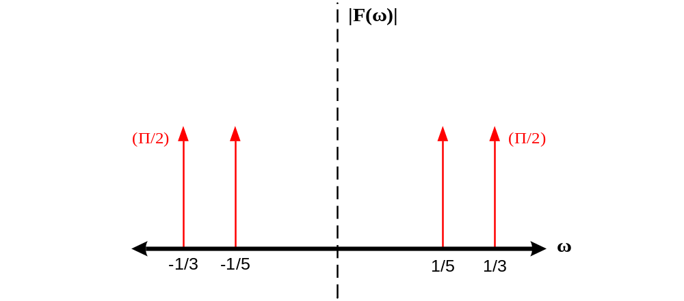

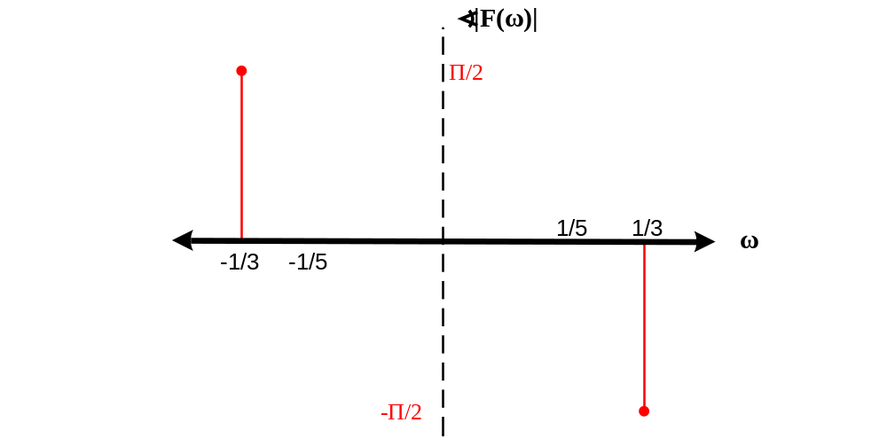
Fundamental Period:
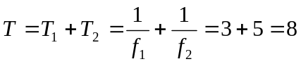

** Part B **

